

Manufacturing Benefits

Two Trees Olive Oil offers a benefits program for its regular full-time and regular part-time Manufacturing employees. However, the existence of these programs does not signify that an employee will necessarily be employed for the required time necessary to qualify for the benefits included in and administered through these programs.

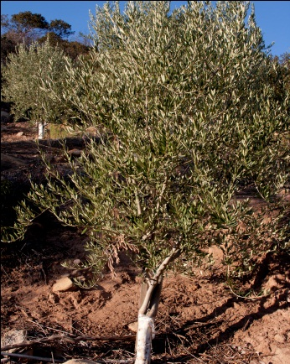

Horticultural Benefits

Two Trees Olive Oil offers a benefits program for its regular full-time and regular part-time Nursery and Orchard employees. However, the existence of these programs does not signify that an employee will necessarily be employed for the required time necessary to qualify for the benefits included in and administered through these programs.